Mediclinic Rooftop PV Projects

September 2021 Asset Monthly Report

Prepared for:

Moshesh Partners

Reference: HAR_215_Moshesh Mediclinic Performance Report

02 November 2022

Document Control

|  |  |  |  |
| --- | --- | --- | --- |
| **Responsible for** | **Name** | **Date** | **Signature** |
| Content | Mutali Nepfumbada | 31 October 2022 |  |
| Checked | Thulani Ndaba | 01 November 2022 |  |
| Approved | Adam Terry | 02 November 2022 |  |
| Copyright: | Commercial in Confidence | Document Reference: | HAR_215_Moshesh Mediclinic Performance Report |
| Signatures in this approval box have checked this document in line with quality procedures requirements  This document has been prepared by Harmattan with all reasonable skill and care. The document contains information from sources and data which we believe to be reliable, but we have not confirmed that reliability and make no representation as to their accuracy or completeness.  The document is confidential to the Client and Harmattan accepts no responsibility to any third party to whom information in this proposal may be disclosed. No part of this document may be reproduced without the prior written approval of Harmattan. | | | |

Table of Contents

1. Introduction 4

1.1. Dataroom 4

1.2. Scope of Work 4

1.3. Site Visits 4

1.4. Report Layout and Risk Assessment Scale 4

2. Executive Summary 1

2.1. Portfolio Overview 1

2.2. Performance Summary 2

2.2.1. Highveld Solar PV 2

2.2.2. Durbanville Solar PV 2

2.2.3. Midstream Solar PV 2

2.2.4. Hermanus Solar PV 2

2.2.5. Vergelegen Solar PV 2

2.3. Key Risks and Recommendations 1

3. O&M Contract 3

4. Portfolio Finance 3

4.1. PPA Rates 3

4.2. Revenue to Date 4

5. Technical Portfolio Overview 5

6. Highveld Technical Performance 6

6.1. Performance Summary 6

6.2. System Design 6

6.3. Data Analysed 6

6.4. Irradiation vs Forecast 7

6.5. Availability vs Forecast 8

6.6. Performance Ratio vs Forecast 8

6.7. Production vs Forecast 9

7. Durbanville Technical Performance 11

7.1. Summary 11

7.2. System Design 11

7.3. Data Analysed 11

7.4. Irradiation vs Forecast 12

7.5. Durbanville Availability vs Forecast 13

7.6. Durbanville Performance Ratio vs Forecast 14

7.7. Production vs Forecast 14

8. Midstream Technical Performance 17

8.1. Summary 17

8.2. System Design 17

8.3. Data Analysed 17

8.4. Midstream Irradiation vs Forecast 18

8.5. Midstream Availability Vs Forecast 19

8.6. Midstream Performance Ratio Vs Forecast 20

8.7. Midstream Production Vs Forecast 21

9. Hermanus Technical Performance 23

9.1. Summary 23

9.2. System Design 23

9.3. Data Analysed 23

9.4. Hermanus Irradiation vs Forecast 24

9.5. Hermanus Availability vs Forecast 25

9.6. Hermanus Performance Ratio vs Forecast 26

9.7. Hermanus Production vs Forecast 27

10. Vergelegen Technical Performance 29

10.1. Summary 29

10.2. System Design 29

10.3. Data Analysed 30

10.4. Vergelegen Irradiation Vs Forecast 30

10.5. Vergelegen Availability vs Forecast 31

10.6. Vergelegen Performance Ratio vs Forecast 32

10.7. Vergelegen Production vs Forecast 33

11. Events 36

11.1. Health and Safety 36

11.2. Scheduled Maintenance 36

11.3. Unscheduled Maintenance 36

11.4. Spare Parts 37

12. Documents Reviewed 38

A1. Site Visit Report – Vergelegen 39

B1. Site Visit Report – Midstream 40

C1. Site Visit Report – Durbanville 41

D1. Site Visit Report – Hermanus 42

E1. Site Visit Report – Highveld 43

List of Figures

Figure 2‑1: Project Locations 1

Figure 4‑1: Revenue to Date vs Forecast 4

Figure 6‑1: Highveld Actual Irradiation Vs Forecast Irradiation 7

Figure 6‑2: Highveld Actual Availability Vs Forecast Availability 8

Figure 6‑3: Highveld Actual PR Vs Forecast PR 9

Figure 6‑4: Highveld Production Vs Forecast 10

Figure 7‑1: Durbanville Actual Irradiation Vs Forecast 12

Figure 7‑2: Durbanville Actual Availability Vs Forecast 13

Figure 7‑3: Durbanville PR Vs Forecast 14

Figure 7‑4: Durbanville Production Vs Forecast 15

Figure 7‑5: Module Shading 16

Figure 8‑1: Midstream Actual Irradiation Vs Forecast 18

Figure 8‑2: Midstream Actual Availability Vs Forecast 19

Figure 8‑3: Midstream PR Vs Forecast 20

Figure 8‑4: Midstream Production Vs Forecast 21

Figure 8‑5: Midstream Soiling 22

Figure 9‑1: Hermanus Actual Irradiation Vs Forecast 24

Figure 9‑2: Hermanus Actual Availability Vs Forecast 25

Figure 9‑3: Hermanus Actual Availability Vs Irradiation 26

Figure 9‑4: Hermanus PR Vs Forecast 27

Figure 9‑5: Hermanus Production Vs Forecast 28

Figure 10‑1: Vergelegen Actual Irradiation Vs Forecast 31

Figure 10‑2: Vergelegen Actual Availability Vs Forecast 32

Figure 10‑3: Vergelegen PR Vs Forecast 33

Figure 10‑4: Vergelegen Production Vs Forecast 34

Figure 10‑5: Vergelegen Production Vs Forecast 34

List of Tables

Table 1‑1: Risk Definitions Key 5

Table 2‑1: Project Overview 1

Table 4‑1: PPA Rates 3

*Table 3‑2: Project Revenue Overview* 4

Table 6‑1: Highveld Project Overview 7

*Table 4‑3: Highveld irradiation and Forecast* 7

Table 4‑4: Highveld Availability and Forecast 8

*Table 4‑5: Highveld PR and Forecast* 8

*Table 4‑2: Hermanus Production and Forecast* 9

Table 7‑1: Durbanville Project Overview 10

*Table 5‑3: Durbanville irradiation and Forecast* 10

*Table 5‑4: Durbanville Availability and Guaranteed* 10

*Table 5‑5: Durbanville PR and Forecast* 11

Table 5‑2: Durbanville Production and Forecast 11

Table 8‑1: Midstream Project Overview 13

*Table 6‑3: Midstream Irradiation and Forecast* 13

*Table 6‑4: Midstream Availability and Guaranteed* 13

*Table 6‑5: Midstream PR and Forecast* 14

*Table 6‑2: Midstream Production and Forecast* 14

Table 9‑1: Hermanus Project Overview 15

*Table 7‑3: Hermanus irradiation and Forecast* 15

*Table 7‑4: Hermanus Availability and Forecast* 16

*Table 7‑2: Hermanus Production and Forecast* 16

*Table 7‑5: Hermanus PR and Forecast* 16

Table 7‑2: Hermanus Production and Forecast 17

Table 10‑1: Vergelegen Project Overview 18

*Table 8‑3: Vergelegen irradiation and Forecast* 18

Table 8‑4: Vergelegen Availability and Guaranteed 18

*Table 8‑5: Vergelegen PR and Forecast* 19

*Table 8‑2: Vergelegen Production and Forecast* 21

Abbreviations

|  |  |
| --- | --- |
| COD | Commercial Operating Date |
| HSE | Health and Safety and Environment |
| kWh | Kilo Watt Hour |
| OPEX | Operating expenses |
| PPA | Power Purchase Agreement |
| PR | Performance Ratio |
| SCADA | Supervisory control and data acquisition |
| YTD | Year-to-date |

# Introduction

Harmattan Pty (Ltd) (“Harmattan”) has been appointed by Moshesh Partners (the “Client”) to provide asset management support for its rooftop and carport PV assets at various Mediclinic sites across South Africa. The projects were all installed by ACES (Operator/ EPC) who is now acting as the O&M contractor (the “Contractor”).

## Dataroom

Harmattan was provided with reports and documentation by dataroom and various emails and information received up until 20 September 2021 was reviewed as part of this assessment.

Link: <https://drive.google.com/drive/u/1/folders/1mzGbgbADKsgF5-OpjCuji_YpA79gh0k6>

## Scope of Work

The scope of work is fully described in Harmattan proposal “*HAR_P215_MOSHESH_MediclinicAssetManagement _v2”*, dated 15 July 2021”.

The purpose of this report is to consider the initial operational performance of the projects, highlight any deviations from expectations and make recommendations to improve performance (where possible). The projects under consideration are Durbanville, Hermanus, Highveld, Midstream and Vergelegen (each a “Project”, together the “Portfolio”).

## Site Visits

Harmattan conducted operational site visits to the Vergelegen, Midstream and Durbanville, and Hermanus projects six months after commercial operations began. These reports form Appendices A, B, C and D to this document.

Site visits will be conducted to the Highveld site upon confirmation of dates with the contractor.

## Report Layout and Risk Assessment Scale

Key findings and recommendations to the Client are highlighted in a summary table in Section 2 of the report. The table is colour coded and includes a narrative summary of the overall findings. A detailed summary of the documents reviewed is included in Section 9 of the report. Where possible, Harmattan will confirm whether review items are consistent with market norms / standards and across all Project documentation. Where Harmattan identifies an omission, error, inconsistency, or deviation from our expectations, an issue will be flagged, analysed, and assigned a risk rating as outlined in Table *1*‑*1*.

For all items, where an issue is identified, a risk category and colour code are allocated. Categorisation is achieved by making a qualitative assessment of the probability of the occurrence of the issue and the severity of the impact of the issue and allocating a tag Critical © / High (H) / Medium (M) / Low (L) / Negligible (N) and associated colour code to each issue (together with a brief explanation of why the tags were chosen). These tags are then multiplied in a range of combinations to yield a qualitative risk categorisation (see graphic below). This categorisation of risk allows for the prioritisation of the issues originally identified and brings a degree of focus to the subsequent mitigation process. If no risk is present / relevant, then the categorisation is summarised as, Not Applicable, (N/A). Harmattan highlights that a simple, non-numerical, approach has been adopted to maintain the simplicity and functionality of the method and to avoid unproductive debates around the calibration of the categorisation components.

|  |  |  |
| --- | --- | --- |
| **Key** | **Definition** | **Description** |
| **C** | **Critical** | Risk of critical negative influence on project/investment outcome |
| **H** | **High** | Risk of high negative influence on project/investment outcome |
| **M** | **Medium** | Risk of medium negative influence on project/investment outcome. |
| **L** | **Low** | Risk of low negative influence on project/investment outcome. |
| **N** | **Negligible** | Risk of negligible negative influence on project/investment outcome. |
| **N/A** | **Not Applicable** | No risk present/relevant. |
| **TBC** | **Awaiting**  **Information** | Additional information required to enable Harmattan to opine on the risk. |

Table 1‑1: Risk Definitions Key

# Executive Summary

## Portfolio Overview

The following map shows the location of Moshesh Rooftop PV Portfolio operating sites. The sites are in the Gauteng and Western Cape Provinces of South Africa.

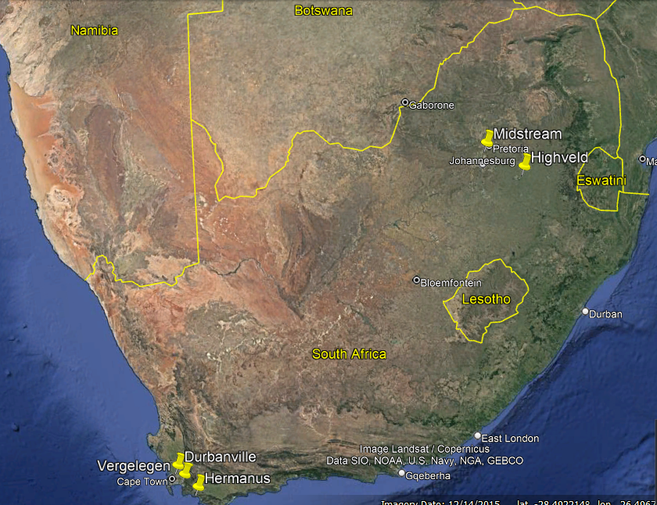

Figure ‑1: Project Locations

Table 2‑1 provides an overview of the Portfolio.

|  |  |  |  |
| --- | --- | --- | --- |
| **Name** | **COD (Commercial Operation Date)** | **Design Capacity DC/AC (kW)** | **Installed**  **Capacity DC/AC (kW)** |
| Moshesh Mediclinic Durbanville (“Durbanville”) | 11 November 2021 | 704.6 / 650 | 705.7 / 650 |
| Moshesh Mediclinic Hermanus Solar PV (“Hermanus”) | 10 March 2022 | 211.7 / 200 | 211.7 / 220 |
| Moshesh Mediclinic Highveld Solar PV (“Highveld”) | 30 March 2022 | 263 / 250 | 258.9 / 250 |
| Moshesh Mediclinic Midstream Solar PV (“Midstream”) | 27 October 2021 | 227.9 / 200 | 227.9 / 220 |
| Moshesh Mediclinic Vergelegen Solar PV (“Vergelegen”) | 28 October 2021 | 697.1 / 650 | 689.6 / 650 |

Table 2‑: Project Overview

## Performance Summary

The following summary describes the performance of the facilities since COD:

### Highveld Solar PV

* Production is 27097 KWh with a variance of -31.25 % below the P50 Forecast.
* Irradiation is 198 kWh/m2 with a variance of 4.69 % below P50 Forecast.
* Availability is 81 % with a variance of -15.17 % above the warranted availability.
* PR is 52 % with a variance of -34.07 % below warranted availability.

### Durbanville Solar PV

* Production is 58368 KWh with a variance of -37.56 % below the P50 Forecast.
* Irradiation is 137 kWh/m2 with a variance of -7.96 % below P50 Forecast.
* Availability is 96 % with a variance of 1.31 % above the warranted availability.
* PR is 60 % with a variance of 60 % below warranted availability.

### Midstream Solar PV

* Production is 24113 KWh with a variance of -27.45 % below the P50 forecast.
* Irradiation is 183 kWh/m2 with a variance of 2.15 % below P50 Forecast.
* Availability is 84 % with a variance of -11.66 % above the warranted availability.
* PR is 58 % with a variance of -26.83 % below warranted availability.

### Hermanus Solar PV

* Production is 23106 KWh with a variance of -17.89 % below the P50 Forecast.
* Irradiation is 153 kWh/m2 with a variance of 0.36 % below P50 Forecast.
* Availability is 80 % with a variance of -15.63 % above the warranted availability.
* PR is 70 % with a variance of -20.14 % below warranted availability.

### Vergelegen Solar PV

* Production is 73643 KWh with a variance of -10.69 % below the P50 Forecast.
* Irradiation is 133 kWh/m2 with a variance of -8.55 % below P50 Forecast.
* Availability is 93 % with a variance of -1.65 % above the warranted availability.
* PR is 79 % with a variance of -2.71 % below warranted availability.

It is noted that all four of the above projects have been subject to numerous loadshedding events which will have contributed to the lower-than-expected levels of production.

## Key Risks and Recommendations

|  |  |  |  |
| --- | --- | --- | --- |
| **Key Risks** | **Description** | **Risk Rating** | **Recommendations** |
| Portofilo Key risk | We have reviewed the plant and have noted the following issues:   * The production of all the plants is below forecast. The Operator has stated that the loss in production was dominated by Eskom load shedding, resulting in inverter downtime due to the anti-islanding function on the inverter. * We have noted that no irradiation data was available prior to April 2022 for Midstream, Durbanville and Vergelegen projects. * We have noted data gaps in the measurement of daily irradiation across the different sites, which makes it difficult to evaluate whether lower irradiation than forecast played a role in the underperformance of the plants and the lower-than-expected PR values achieved. * We have noted that no unscheduled maintenance report, biannual inspection checklist, thermal reports were not provided for Highveld. * No unscheduled maintenance reports were provided for midstream * The underperformance of the plant has resulted in revenue losses due to production losses. | **H** | We recommend:   * Performing a cost benefit analysis of various options that could be employed to allow the PV systems to operate during periods of loadshedding. * Moshesh communicate with Mediclinic on whether they would allow solutions which enable the integration of the PV systems and the backup generators on each site. * We recommend that the Operator provided the missing reports for midstream and Vergelegen. * We recommend that the Operator procure the missing data prior April 2022 for Midstream, Vergelegen, Durbanville * We recommend reloading the missing daily irradiation data to the SCADA |
| Vergelegen  Technical Risk | We also note that the inverters were operating at a high temperature of 50 ˚C, close to the maximum temperature of 60 ˚C. Operating at this temperature for an extended time will result in production losses and increase the levels of wear and tear on the inverters. The inverter’s high operating temperature is due to poor ventilation. Unless this issue is quickly rectified, we expect high losses in summer and possibly reduced inverter lifetimes. | **H** | We recommend ACES to submit specifications for the cooling required to keep the inverter at a safe operating temperature. Harmattan will review the specifications and costings provided. |
| Midstream  Technical Risk | We have noticed soiling on the modules which could have influenced the overall performance. The modules were washed In August 2022 after 10 months operation. The soiling was noted during the site visit on 23 September 2022. | **H** | We recommend monitoring the soiling for at least six months to determine if additional cleaning is needed, as the modules were heavily soiled, as seen during the site visit. |
| Durbanville  Technical Risk | The total production since COD is below forecast which may have been influenced by the shading from nearby trees and the frequent Eskom load shedding due to the anti-islanding function on the inverter. | **H** | We recommend the ACES purchase the missing data from Solcast and cut down or trim trees that shade the panels |
| Performance Guarantee | Harmattan note that Durbanville, Vergelegen, and Midstream started operation in October 2022. However, we were not provided with the irradiance data prior to March 2022. As such we cannot use the formula from the O&M contract to adjust generation for 12 months.  Performance Guarantee after Services Start Date  The Operator guarantees to the Owner that the Facility will reach a minimum of 90% of “Generation Adjusted” in a consecutive period of 12 months. | **H** | Harmattan recommends:   * Only consider data from April 2022 to November 2022 for generation adjustment. * Inquire whether ACES can use satellite data from another site near the Moshesh projects. |
| Major Spare parts | Harmattan notes that no spare parts are kept on site as agreed in discussions with Moshesh and Harmattan management and will be reflected in the contract. The Operator has stated that minor spare parts are in stock in Cape Town and Johannesburg. Major spares will be kept in Cape Town. We note that only keeping the major spare parts in Cape Town present a problem for plants outside of Cape Town since it would require longer lead time to deliver the spare to site, resulting in higher production losses | **M** | Harmattan recommends keeping some major spare parts in Johannesburg although we note that having spare parts only in Cape Town has had little effect on performance to date. |



Table 2‑2: Key Risks

# O&M Contract

Harmattan notes that the O&M contract between Moshesh and ACES Africa (Operator) has not yet been signed. This poses a risk to Moshesh as it is unable to claim the penalties for underperformance set forth in the contract. Harmattan notes that the Operator submits monthly reports and conducts semi-annual maintenance inspections as specified in the draft O&M contract.

Harmattan has reviewed the draft O&M contract and noted the following:

* Durbanville, Vergelegen and Midstream started operation in October 2022, yet no irradiance data was provided prior to April 2022. We therefore cannot use the following formula in the O&M contract to adjust generation for 12 months of operation.

Equation 1: Generation Adjustment (O&M Contract)

* The draft O&M contract does not include requirements for reporting on:
  + Major spare parts consumed;
  + Spare parts in stock as per the spare parts list and their location;
  + Scheduled maintenance performed monthly;
  + Unscheduled Maintenance; and
  + HSE issues.

Harmattan recommends that the contract is amended to include the above reporting requirements and that ACESACES purchase the missing irradiance data from Solcast to allow completion of the performance assessments.

# Portfolio Finance



## PPA Rates

Revenues are based on actual production and the rate agreed upon between each Mediclinic site and Moshesh under the Power Purchase Agreements (PPA) as described in Table 3-1 below

|  |  |  |
| --- | --- | --- |
| **Plant** | **PPA Rate (ZAR/kWh)** | **Applicable Year** |
| Durbanville | 0.6066 | 11 November 2021 - 10 November 2022 |
| Vergelegen | 0.6148 | 28 October 2021 - 27 October 2022 |
| Highveld | 0.6589 | 30 March 2022 -29 March 2023 |
| Midstream | 0.6741 | 27 October 2021 - 26 October 2022 |
| Hermanus | 0.7944 | 10 March 2022 - 9 March 2023 |

Table ‑: PPA Rates

The Moshesh/Mediclinic PPA rates increase by 6% every 12 months from COD.

Forecast revenues are based on the P50 Helioscope simulation performed during the pre-construction phase and have not been adjusted to reflect actual irradiation or the installed capacity.

Actual revenue is based upon production as recorded by the SCADA and the PPA rates.

## Revenue Year to Date

The following graph shows the revenue against the budgeted revenue.

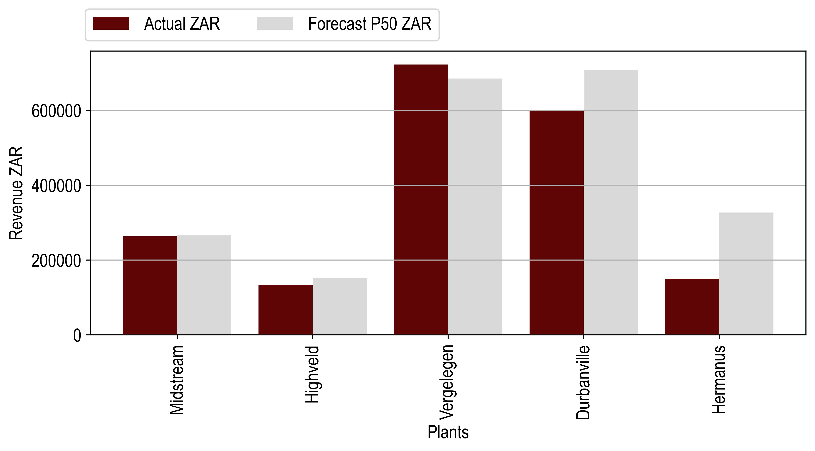

*Figure 3‑1: Revenue to Date*

|  |  |  |  |
| --- | --- | --- | --- |
| **Revenue (ZAR)** | | | |
| **Plants** | **Actual** | **Forecast** | **Delta (%)** |
| Durbanville | 433541 | 560057 | -22.59 |
| Vergelegen | 465092 | 494569 | -5.96 |
| Highveld | 111329 | 152907 | -27.19 |
| Midstream | 185733 | 207368 | -10.43 |
| Hermanus | 107159 | 117269 | -8.62 |

*Table 3‑2: Project Revenue Overview*



We note that all the plants have been performing below the forecasted revenue, with Durbanville and Highveld showing the most significant deviation from forecast.

In the following sections, we analyse the performance on a per Project basis.

# Technical Portfolio Overview

We have investigated the performance of the Highveld, Durbanville, Midstream, Hermanus and Vergelegen Mediclinic solar PV sites. We evaluated performance by comparing irradiance, availability, performance ratio, and production against forecasts. All sites have underperformed against the forecast. The Operator has stated that the underperformance of each site was dominated by frequent loadshedding which has resulted in curtailment of the sites. This curtailment occurs as the installed grid tied inverters have anti -islanding protection.

Anti-islanding protection is a necessary safety feature which disables PV inverters when the grid enters an islanded condition. This means that the inverter won’t operate during a grid outage event such as Eskom load shedding. This is to protect the grid personnel working on the transmission lines during the outage. If the buildings continue to generate power during a grid outage and potentially feed power to the national grid, this could be fatal to maintenance personnel who are unaware that power is flowing in the lines when the grid is down.

An alternative to this system is to enable the PV systems to operate in an island system and so continue to supply the buildings that the PV system is connected to during time of loadshedding. Under this situation, the PV system would still generate power for direct use in the building, with no export to the external power grid. We note that that the system can only supply part of the load and it must be integrated with a generator, or battery system to allow the invertor to function.

The Operator has suggested installing a genset integrator system, which would connect into the existing Mediclinic backup generator sets. Harmattan has asked the Operator for a quote on the cost of procuring and installing a genset integrator and various other options. Harmattan note that a cost benefit analysis needs to be considered for various options in the market that could be used to solve the problem before deciding whether to install the genset integrator and note that Moshesh would need to communicate with Mediclinic as the genset integrator would be connected to the backup generator.

Harmattan highlights a note of caution here – given the critical nature of Mediclinic’s operations, it is possible that anything that could be seen as interfering with their power supply during a grid outage is a risk. Careful communications will be needed with Mediclinic to allay these fears.

## Data Analysed

The following sections describes the performance of the system. Harmattan compiled performance data data from the SCADA system and and processed the data from January 2022 through to September 2022 using Microsoft Excel. Harmattan has reviewed the data and where possible adjusted the production data for gaps in the data based on the following formula:

Based on this data, irradiance, availability Performance Ratio and Production are analysed. The irradiation data is based on the Solcast satellite data, availability and performance Ratio are calculated from the SCADA. The production is measured using a meter installed onsite.

# Highveld Technical Performance

The following table gives a brief overview of the Highveld PV installation.

|  |  |
| --- | --- |
| **Project Overview** | |
| Design Capacity DC/AC (kW) | 263 / 250 |
| Installed Capacity DC/AC (kW) | 258.9 / 250 |
| Technology | Solarw |
| Project Company | Moshesh Solar PV 1 (Pty) Ltd |
| Address | 46 Barney Molokwane, Trichardt South Africa |
| Commercial Operation Date | 30 March 2022 |

Table 6‑1: Highveld Project Overview



## Irradiation vs Forecast

The following table and graph describe the irradiance of the site compared to the pre-construction Helioscope P50 prediction. Harmattan notes that the irradiance data is satellite-based. We note that some of the irradiation data was not fully captured from April to July 2022.

Harmattan has noted the following after reviewing the daily irradiation SCADA data:

* The irradiance data was not available for 19 days in April 2022;
* The irradiance data was not available for 2 days in May 2022;
* The irradiance data was not available for 25 days in June 2022;
* The irradiance data was not available for 18 days in July 2022;
* The irradiance data was available for the full month in August 2022.

Harmattan adjusted the irradiance P50 forecast by the number of days that data was not available (See Equation 2). Total irradiance is 457kWh with a variance 2.43% below the forecast, as shown in the following table.



We note that the irradiation has been below forecast since COD, except for August 2022 which had a 5.05% above forecast deviation. The August month had no data gaps, this indicates that the irradiation gaps has affected the overall comparison between the forecast and actual performance. Due to high data gaps, it is difficult to tell if the low irradiance is due to poor weather conditions or poor data quality.

|  |  |  |  |
| --- | --- | --- | --- |
| **Irradiation (kWh/m2)** | | | |
| **Month** | **Actual** | **Forecast** | **Delta (%)** |
| Apr 22 | 52 | 57 | -9.85 |
| May 22 | 139 | 145 | -4.49 |
| Jun 22 | 19 | 24 | -17.84 |
| Jul 22 | 61 | 65 | -6.01 |
| Aug 22 | 186 | 177 | 5.05 |
| Sep 22 | 198 | 189 | 4.69 |

*Table 4‑3: Highveld irradiation and Forecast*

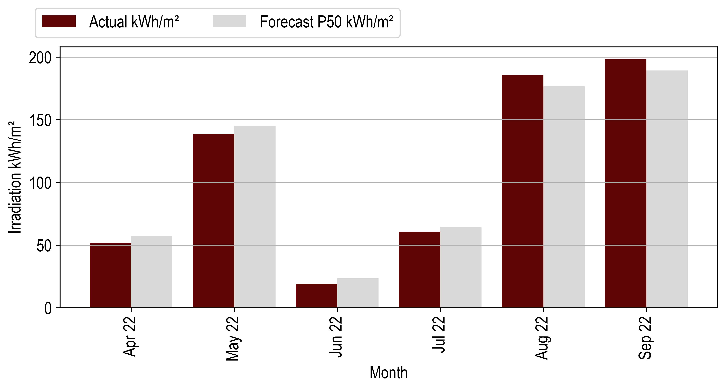

*Figure 4‑2: Highveld Irradiation Vs Forecast*

## Availability vs Forecast



|  |  |  |  |
| --- | --- | --- | --- |
| **Availability (%)** | | | |
| **Month** | **Actual** | **Forecast** | **Delta (%)** |
| Apr 22 | 95 | 95 | 0.0 |
| May 22 | 98 | 95 | 2.75 |
| Jun 22 | 95 | 95 | -0.37 |
| Jul 22 | 95 | 95 | -0.05 |
| Aug 22 | 93 | 95 | -1.78 |
| Sep 22 | 81 | 95 | -15.17 |

Table 4‑4: Highveld Availability and Forecast

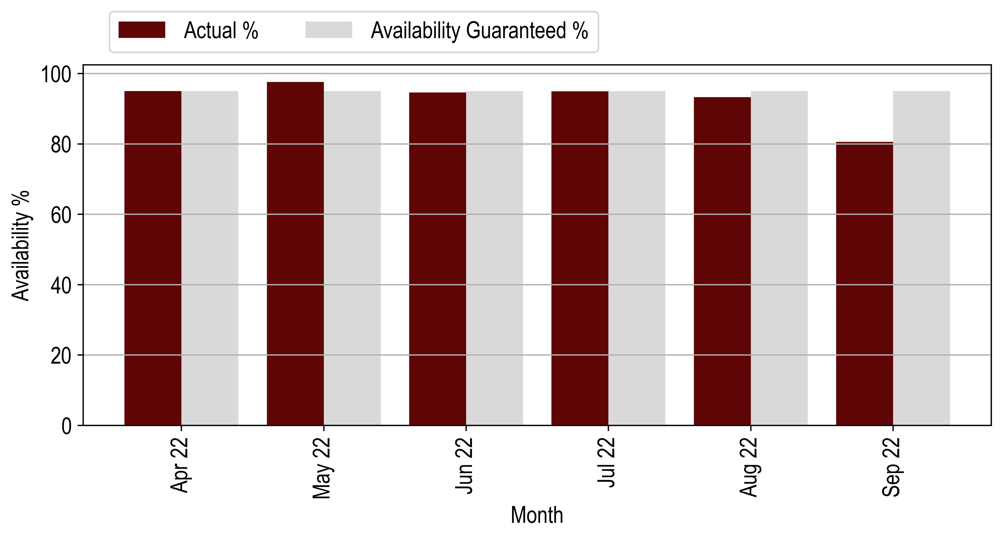

Figure 4‑3: Highveld Availability Vs Forecast

## Performance Ratio vs Forecast

|  |  |  |  |
| --- | --- | --- | --- |
| **Performance Ratio (%)** | | | |
| **Month** | **Actual** | **Forecast** | **Delta (%)** |
| Apr 22 | 70 | 29 | 141.2 |
| May 22 | 67 | 73 | -8.92 |
| Jun 22 | 62 | 13 | 371.39 |
| Jul 22 | 64 | 33 | 91.75 |
| Aug 22 | 65 | 79 | -17.31 |
| Sep 22 | 52 | 79 | -34.07 |

*Table 4‑5: Highveld PR and Forecast*

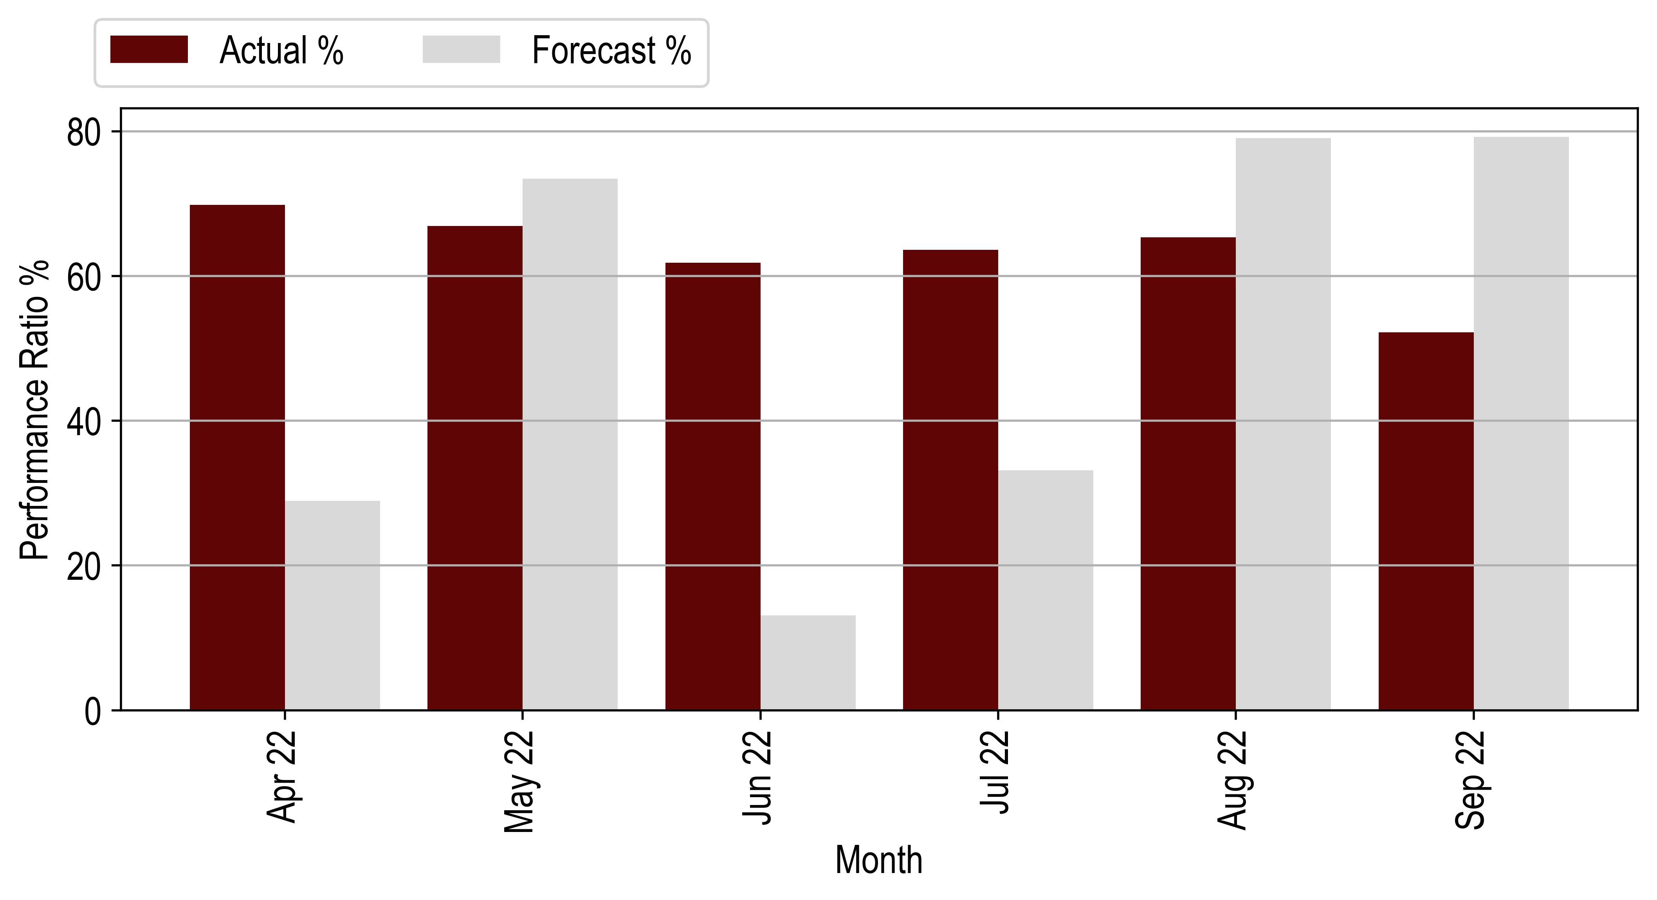

*Figure 4‑4: Highveld PR Vs Forecast*



## Production vs Forecast







|  |  |  |  |  |  |
| --- | --- | --- | --- | --- | --- |
| **Month** | **Production (kWh)** | | |  | **Actual vs Weather Adjusted Forecast (%)** |
|  | **Original Forecast** | **Weather Adjusted Forecast** | **Actual Production** |
| Apr 22 | 32408 | 29215 | 21644 | -33.21 | -25.92 |
| May 22 | 32008 | 30569 | 28195 | -11.91 | -7.77 |
| Jun 22 | 29209 | 23997 | 17910 | -38.69 | -25.37 |
| Jul 22 | 32059 | 30133 | 21623 | -32.55 | -28.24 |
| Aug 22 | 36696 | 38548 | 30455 | -17.01 | -20.99 |
| Sep 22 | 39414 | 41263 | 27097 | -31.25 | -34.33 |
| **Total** | **201794** | **193725** | **146924** | **-27.19** | **-24.16** |

*Table 4‑2: Hermanus Production and Forecast*

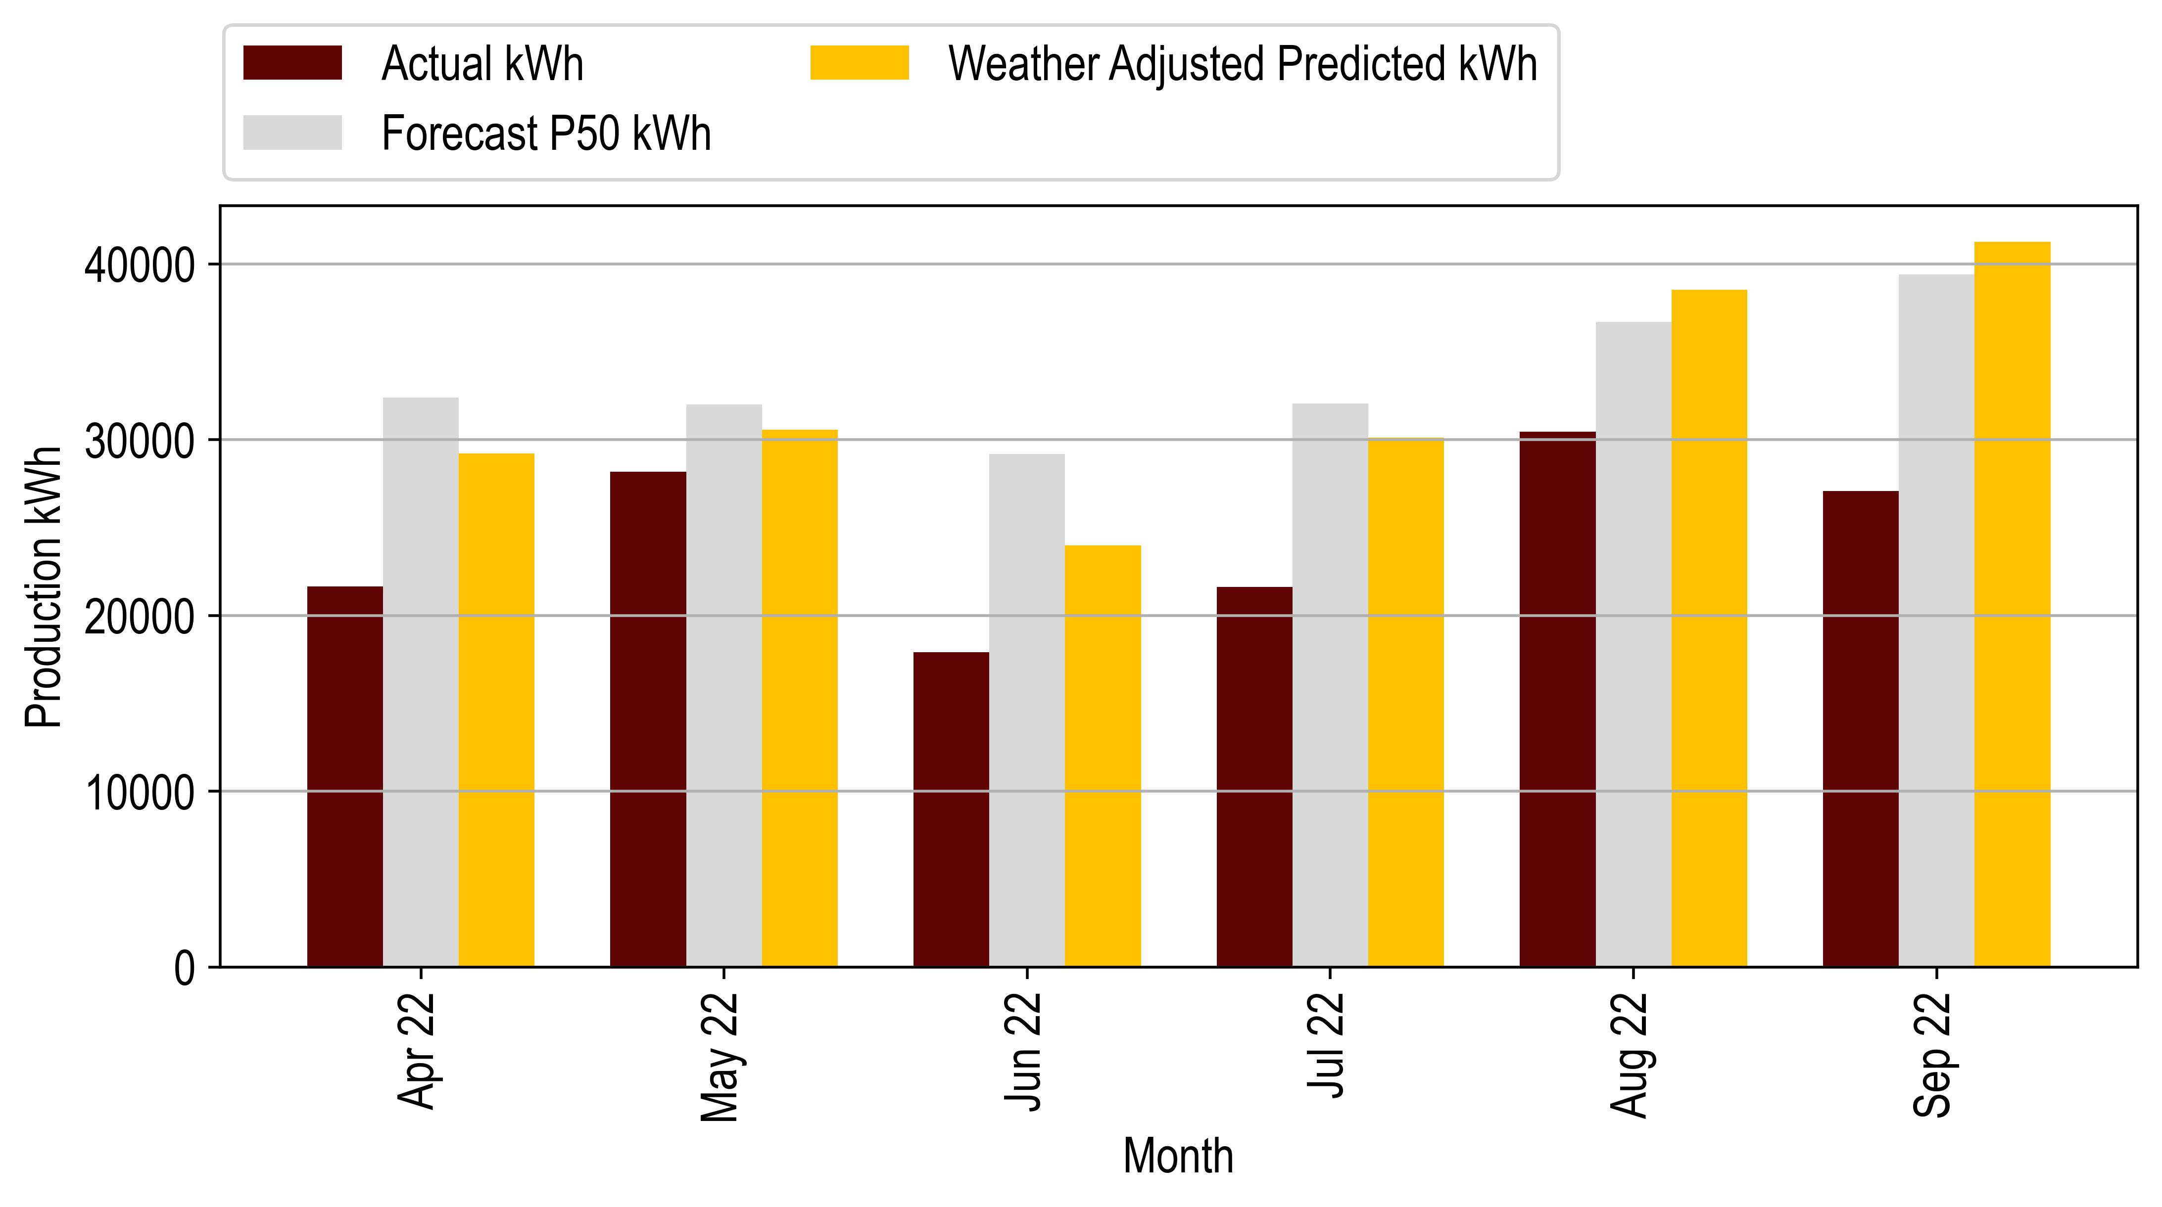

*Figure 4‑1: Hermanus Production Vs Forecast*

# Durbanville Technical Performance

The following table gives a brief overview of the Durbanville PV installation

|  |  |
| --- | --- |
| **Project Overview** | |
| Design Capacity DC/AC (kW) | 704.6 / 650 |
| Achieved Capacity DC/AC (kW) | 705.7 / 650 |
| Technology | Solar |
| Project Company: | Moshesh Solar PV 1 (Pty) Ltd |
| Address: | Wellington Road Durbanville South Africa |
| Commercial Operation Date | 11 November 2022 |

Table 7‑1: Durbanville Project Overview



## Irradiation vs Forecast

|  |  |  |  |
| --- | --- | --- | --- |
| **Irradiation kWh/m2** | | | |
| **Month** | **Actual** | **Forecast** | **Delta (%)** |
| Jan 22 | 251 | 255 | -1.79 |
| Feb 22 | 200 | 205 | -2.62 |
| Mar 22 | 180 | 189 | -4.78 |
| Apr 22 | 137 | 130 | 5.48 |
| May 22 | 93 | 94 | -0.84 |
| Jun 22 | 81 | 76 | 7.44 |
| Jul 22 | 81 | 85 | -4.98 |
| Aug 22 | 103 | 110 | -6.54 |
| Sep 22 | 137 | 149 | -7.96 |

*Table 5‑3: Durbanville irradiation and Forecast*

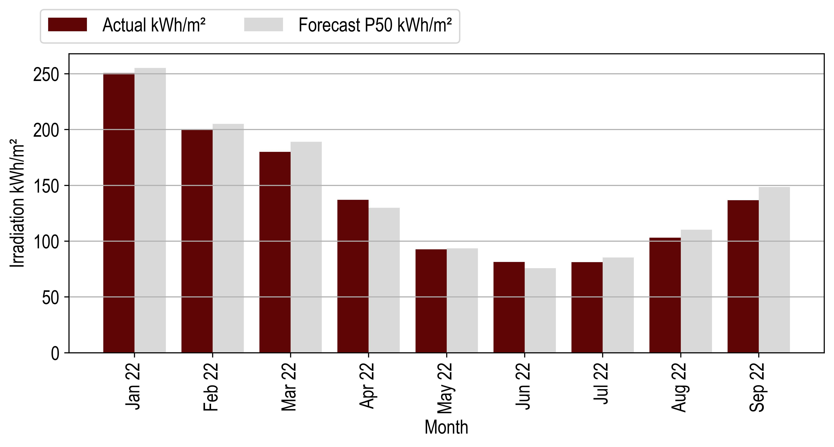

*Figure 5‑4: Durbanville Irradiation Vs Forecast*



## Durbanville Availability vs Forecast.

|  |  |  |  |
| --- | --- | --- | --- |
| **Availability (%)** | | | |
| **Month** | **Actual** | **Forecast** | **Delta (%)** |
| Jan 22 | 89 | 95 | -6.74 |
| Feb 22 | 99 | 95 | 4.26 |
| Mar 22 | 100 | 95 | 5.26 |
| Apr 22 | 97 | 95 | 1.86 |
| May 22 | 91 | 95 | -4.67 |
| Jun 22 | 95 | 95 | 0.27 |
| Jul 22 | 89 | 95 | -5.99 |
| Aug 22 | 100 | 95 | 5.0 |
| Sep 22 | 96 | 95 | 1.31 |

*Table 5‑4: Durbanville Availability and Guaranteed*

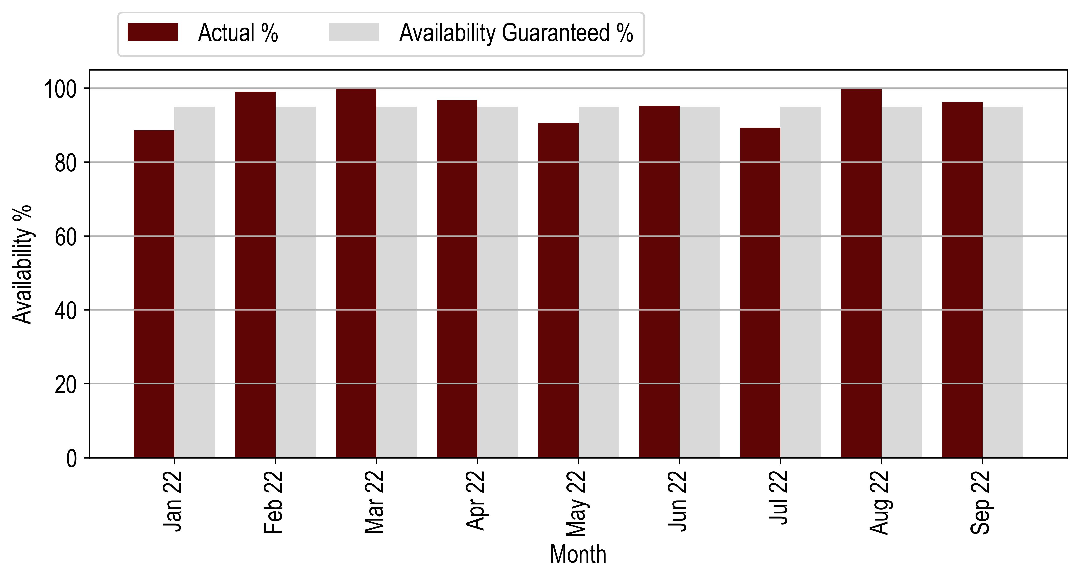

*Figure 5‑5: Durbanville Availability Vs Forecast*



## Durbanville Performance Ratio vs Forecast



|  |  |  |  |
| --- | --- | --- | --- |
| **Performance Ratio (%)** | | | |
| **Month** | **Actual** | **Forecast** | **Delta (%)** |
| Jan 22 | 57 | 0 | 0 |
| Feb 22 | 65 | 0 | 0 |
| Mar 22 | 71 | 0 | 0 |
| Apr 22 | 73 | 62 | 16.74 |
| May 22 | 92 | 77 | 20.02 |
| Jun 22 | 84 | 80 | 4.38 |
| Jul 22 | 78 | 80 | -3.4 |
| Aug 22 | 79 | 80 | -0.74 |
| Sep 22 | 61 | 79 | -23.38 |

*Table 5‑5: Durbanville PR and Forecast*

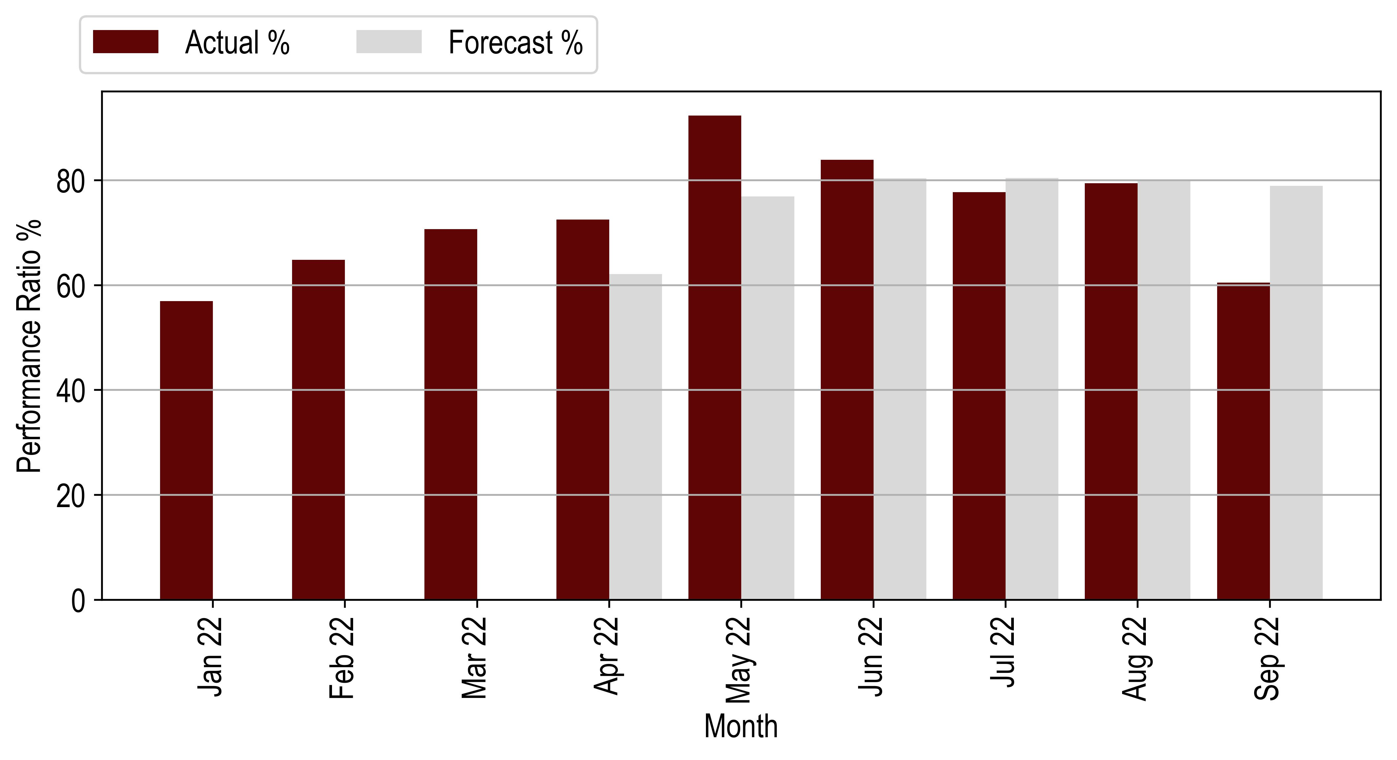

*Figure 5‑6: Durbanville PR Vs Forecast*

## Production vs Forecast



|  |  |  |  |  |  |
| --- | --- | --- | --- | --- | --- |
| **Month** | **Production (kWh)** | | | **Actual vs Original Forecast (%)** | **Actual vs Weather Adjusted Forecast (%)** |
|  | **Original Forecast** | **Weather Adjusted Forecast** | **Actual Production** |
| Jan 22 | 130944 | 130944 | 100806 | -23.02 | -23.02 |
| Feb 22 | 111814 | 111814 | 91370 | -18.28 | -18.28 |
| Mar 22 | 111969 | 111969 | 89806 | -19.79 | -19.79 |
| Apr 22 | 85868 | 90578 | 70141 | -18.31 | -22.56 |
| May 22 | 68401 | 67829 | 60421 | -11.67 | -10.92 |
| Jun 22 | 58422 | 62770 | 48240 | -17.43 | -23.15 |
| Jul 22 | 64810 | 61580 | 44538 | -31.28 | -27.67 |
| Aug 22 | 77139 | 72093 | 57793 | -25.08 | -19.84 |
| Sep 22 | 93479 | 86034 | 58368 | -37.56 | -32.16 |
| **Total** | **1015200** | **1007965** | **859081** | **-22.59** | **-21.89** |

Table 5‑2: Durbanville Production and Forecast

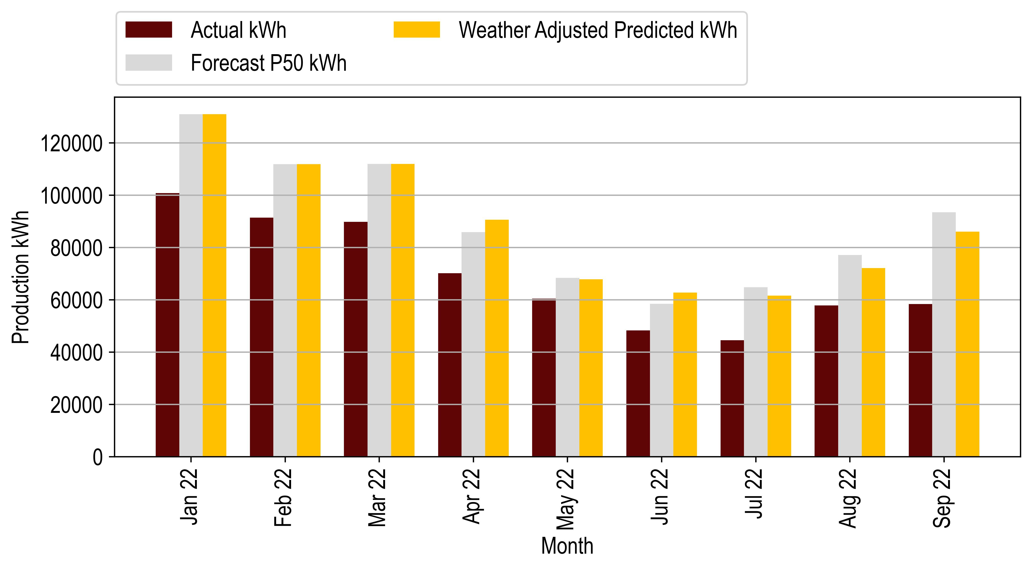

Figure 5‑1: Durbanville Production Vs Forecast



# Midstream Technical Performance

The following table gives a brief overview of the Midstream PV installation.

|  |  |
| --- | --- |
| **Project Overview** | |
| Design Capacity kW DC/AC (kW) | 227.9 / 200 |
| Achieved Capacity DC/AC (kW) | 227.9 / 220 |
| Technology | Solar |
| Project Company: | Moshesh Solar PV 1 (Pty) Ltd |
| Address: | Midstream Drive, Hill Boulevard Midstream Estate, Olifantsfontein. - South Africa |
| Commercial Operation Date | 27 October 2021 |

Table 8‑1: Midstream Project Overview



## Midstream Irradiation vs Forecast



|  |  |  |  |
| --- | --- | --- | --- |
| **Irradiation (kWh/m2)** | | | |
| **Month** | **Actual** | **Forecast** | **Delta (%)** |
| Jan 22 | 182 | 208 | -12.39 |
| Feb 22 | 184 | 176 | 4.56 |
| Mar 22 | 157 | 177 | -11.29 |
| Apr 22 | 127 | 144 | -11.98 |
| May 22 | 131 | 134 | -2.24 |
| Jun 22 | 123 | 119 | 4.09 |
| Jul 22 | 127 | 131 | -3.25 |
| Aug 22 | 164 | 158 | 3.73 |
| Sep 22 | 183 | 179 | 2.15 |

*Table 6‑3: Midstream Irradiation and Forecast*

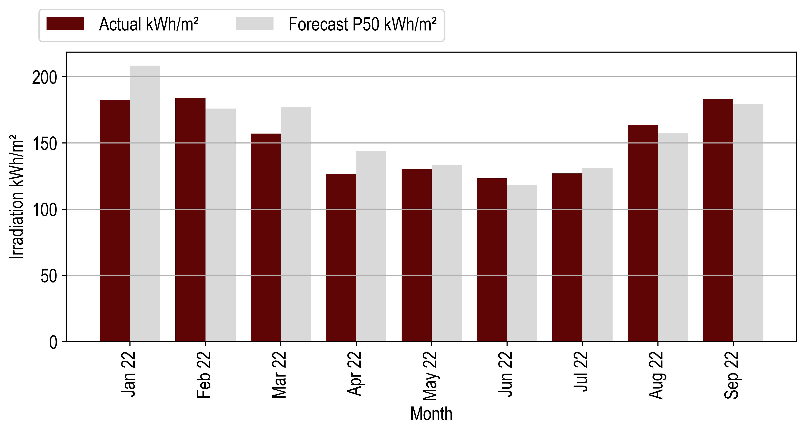

*Figure 6‑2: Midstream Irradiation Vs Forecast*

## Midstream Availability Vs Forecast



|  |  |  |  |
| --- | --- | --- | --- |
| **Availability (%)** | | | |
| **Month** | **Actual** | **Forecast** | **Delta (%)** |
| Jan 22 | 0 | 95 | -100.0 |
| Feb 22 | 64 | 95 | -32.35 |
| Mar 22 | 100 | 95 | 5.26 |
| Apr 22 | 97 | 95 | 1.78 |
| May 22 | 96 | 95 | 0.99 |
| Jun 22 | 100 | 95 | 5.26 |
| Jul 22 | 94 | 95 | -1.29 |
| Aug 22 | 99 | 95 | 3.97 |
| Sep 22 | 84 | 95 | -11.66 |

*Table 6‑4: Midstream Availability and Guaranteed*

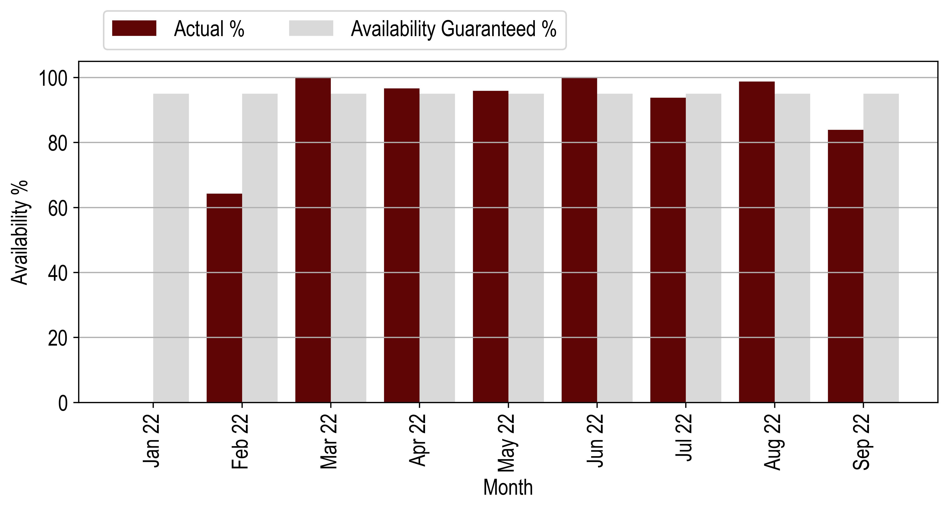

*Figure 6‑3: Midstream Availability Vs Forecast*

## Midstream Performance Ratio Vs Forecast



|  |  |  |  |
| --- | --- | --- | --- |
| **Performance Ratio (%)** | | | |
| **Month** | **Actual** | **Forecast** | **Delta (%)** |
| Jan 22 | 82 | 0 | 0 |
| Feb 22 | 79 | 0 | 0 |
| Mar 22 | 81 | 0 | 0 |
| Apr 22 | 82 | 75 | 9.89 |
| May 22 | 79 | 74 | 6.94 |
| Jun 22 | 77 | 55 | 41.24 |
| Jul 22 | 72 | 66 | 9.35 |
| Aug 22 | 79 | 55 | 45.08 |
| Sep 22 | 58 | 79 | -26.83 |

*Table 6‑5: Midstream PR and Forecast*

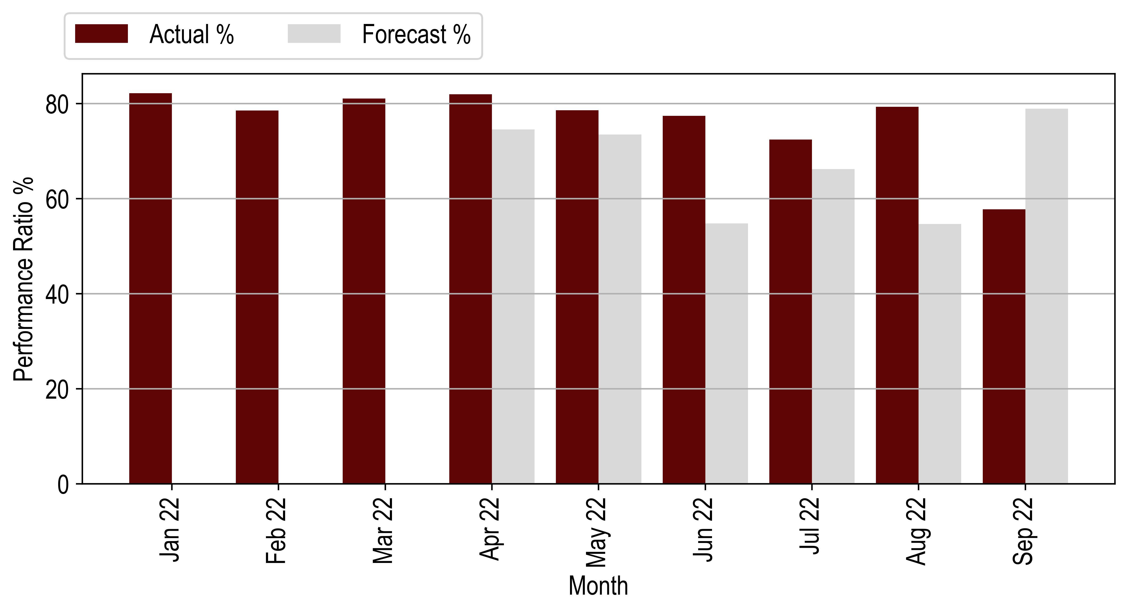

*Figure 6‑4: Midstream PR Vs Forecast*

## Midstream Production Vs Forecast

|  |  |  |  |  |  |
| --- | --- | --- | --- | --- | --- |
| **Month** | **Production (kWh)** | | | **Actual vs Original Forecast (%)** | **Actual vs Weather Adjusted Forecast (%)** |
|  | **Original Forecast** | **Weather Adjusted Forecast** | **Actual Production** |
| Jan 22 | 36357 | 36357 | 34169 | -6.02 | -6.02 |
| Feb 22 | 31491 | 31491 | 32937 | 4.59 | 4.59 |
| Mar 22 | 32436 | 32436 | 29032 | -10.49 | -10.49 |
| Apr 22 | 27152 | 23899 | 23636 | -12.95 | -1.1 |
| May 22 | 26286 | 25698 | 23406 | -10.96 | -8.92 |
| Jun 22 | 23828 | 24803 | 21763 | -8.66 | -12.25 |
| Jul 22 | 26254 | 25402 | 20957 | -20.18 | -17.5 |
| Aug 22 | 30459 | 31596 | 29575 | -2.9 | -6.4 |
| Sep 22 | 33234 | 33947 | 24113 | -27.45 | -28.97 |
| **Total** | **267498** | **265629** | **239589** | **-10.43** | **-9.8** |

*Table 6‑2: Midstream Production and Forecast*

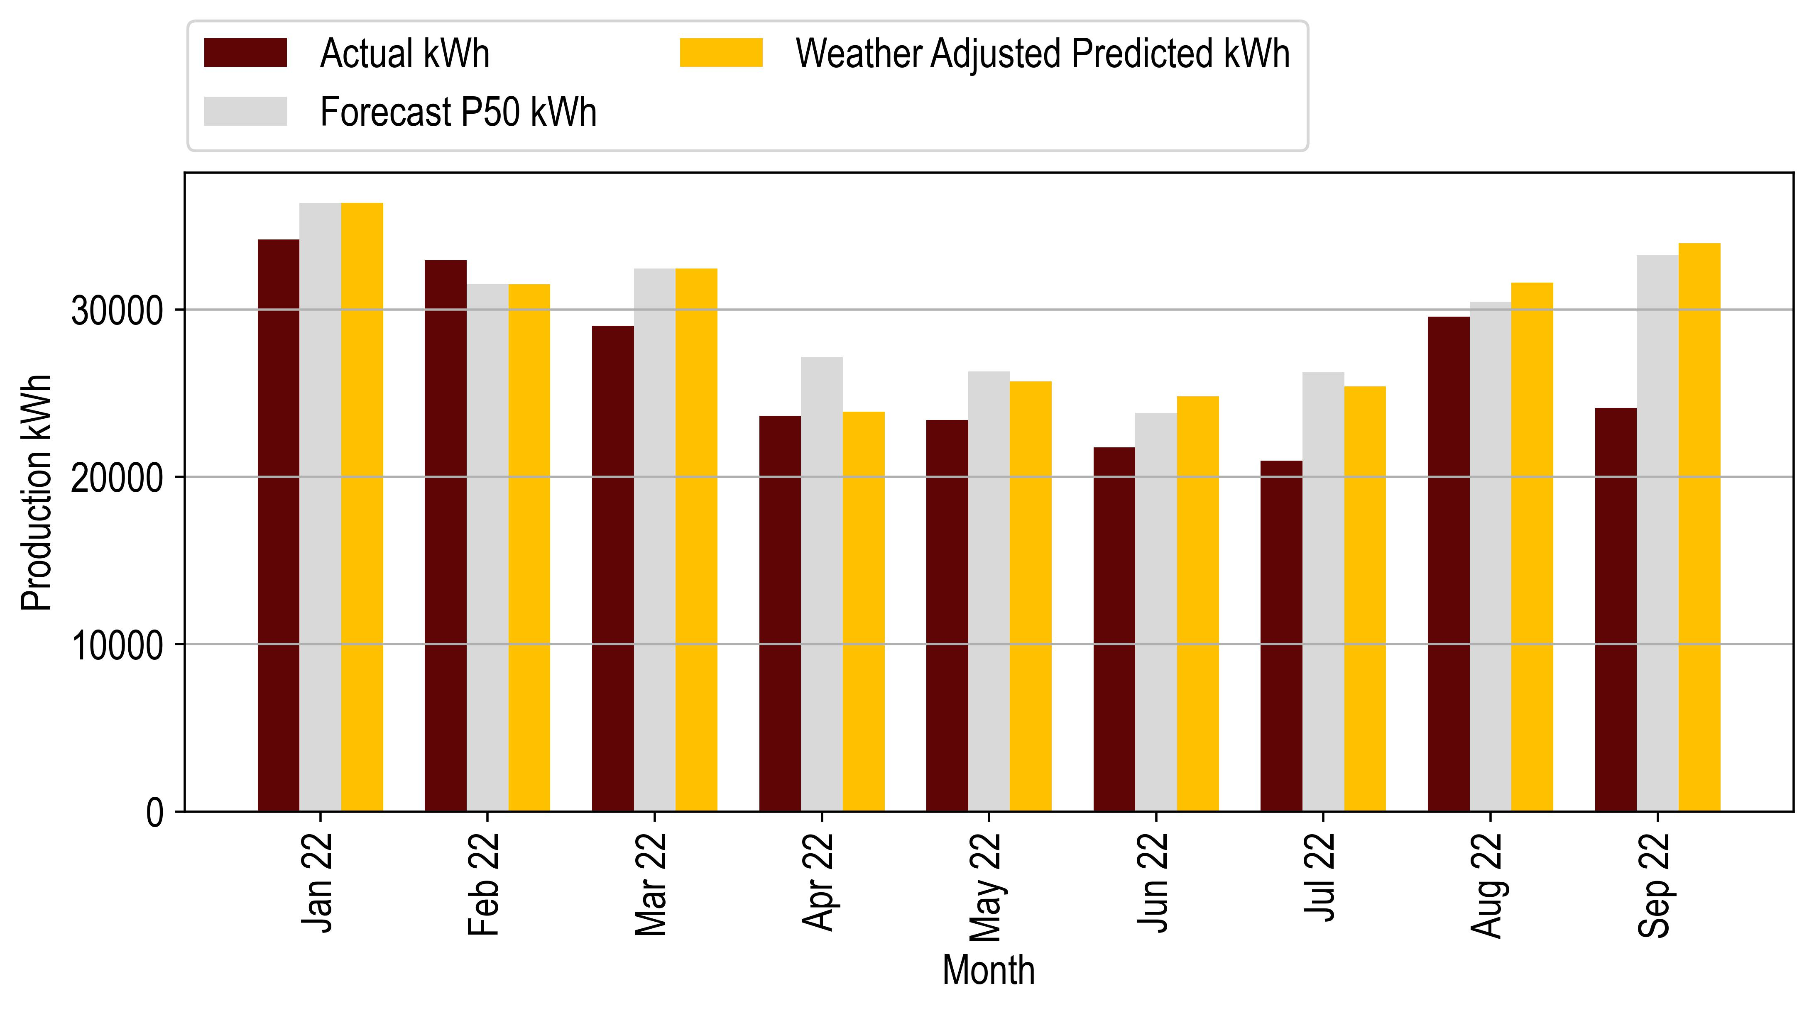



*Figure 6‑1: Midstream Production Vs Forecast*

# Hermanus Technical Performance

The following table gives a brief overview of the Hermanus PV installation.

|  |  |
| --- | --- |
| **Project Overview** | |
| Design Capacity (kW) DC/AC: | 211.7 / 200 |
| Achieved Capacity (kW) DC/AC | 211.7 / 220 |
| Technology | Solar |
| Project Company: | Moshesh Solar PV 1 (Pty) Ltd |
| Address: | Ravenscroft Rd Hermanus – 7,200 – South Africa |
| Commercial Operation Date | 10 March 2022 |

Table ‑: Hermanus Project Overview

## Hermanus Irradiation vs Forecast

The following table and graph describe the irradiance of the site compared to the Helioscope P50 prediction. Harmattan notes that the irradiance measurement is based on the installed pyranometer. The site has been measuring irradiance since April 2022 to the present, and no irradiance data is available prior to that time. We note that some of the irradiation data were not fully captured in the month of April 2022.

Harmattan has noted the following after reviewing the daily irradiation SCADA data:

* The irradiance data was not available for 2 days in April 2022;
* The irradiance data was available for the full months of May-August 2022;

Harmattan has adjusted the irradiance forecast based on the number of data unavailability days (See Equation 2). We have only adjusted the April 2022 dataset, and no adjustments were required for the other datasets. Total irradiance is 542kWh/m2 with a variance of 2.76% above the forecast, as shown in the following table.



|  |  |  |  |
| --- | --- | --- | --- |
| **Irradiation (kWh/m2)** | | | |
| **Month** | **Actual** | **Forecast** | **Delta (%)** |
| Apr 22 | 126 | 128 | -1.65 |
| May 22 | 111 | 104 | 6.44 |
| Jun 22 | 90 | 86 | 3.9 |
| Jul 22 | 94 | 97 | -3.4 |
| Aug 22 | 121 | 119 | 1.84 |
| Sep 22 | 153 | 153 | 0.36 |

*Table 7‑3: Hermanus irradiation and Forecast*

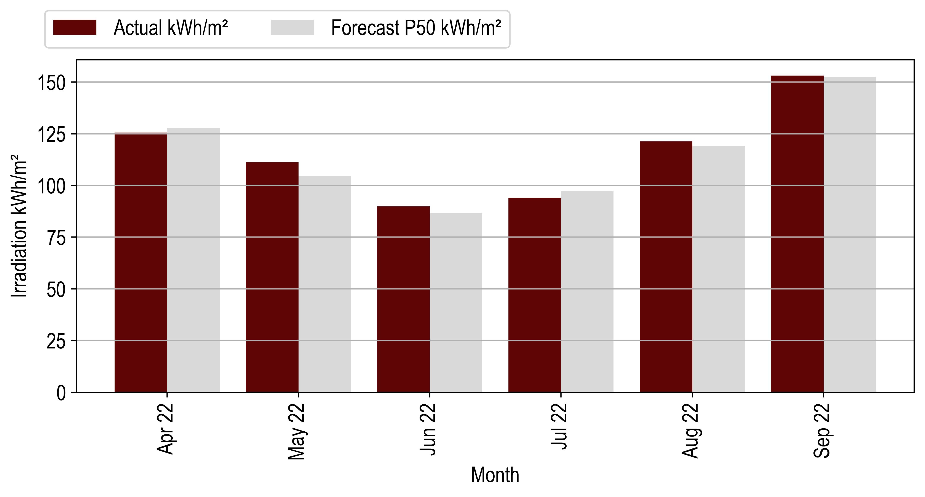

*Figure 7‑3: Hermanus Irradiation Vs Forecast*

The table and figure above show that the irradiation is below forecast in April 2022 and July 2022 and above in May, June, and August 2022. We note that the overall data quality is good with only 2 days of unavailability since COD. We noted that the overall irradiation of the site is above forecast.

## Hermanus Availability vs Forecast



|  |  |  |  |
| --- | --- | --- | --- |
| **Availability (%)** | | | |
| Month | Actual | Forecast | Delta (%) |
| Apr 22 | 93 | 95 | -1.62 |
| May 22 | 96 | 95 | 0.97 |
| Jun 22 | 92 | 95 | -3.35 |
| Jul 22 | 88 | 95 | -7.32 |
| Aug 22 | 100 | 95 | 5.22 |
| Sep 22 | 80 | 95 | -15.63 |

*Table 7‑4: Hermanus Availability and Forecast*

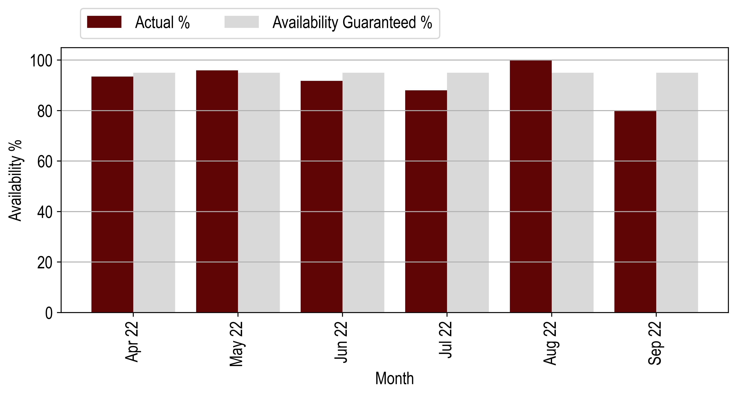

*Figure 7‑4: Hermanus Availability Vs Forecast*

|  |  |  |  |  |  |
| --- | --- | --- | --- | --- | --- |
| **Month** | **Production (kWh)** | | | **Actual vs Original Forecast (%)** | **Actual vs Weather Adjusted Forecast (%)** |
|  | **Original Forecast** | **Weather Adjusted Forecast** | **Actual Production** |
| Apr 22 | 24970 | 24557 | 21947 | -12.11 | -10.63 |
| May 22 | 19205 | 20441 | 19453 | 1.29 | -4.83 |
| Jun 22 | 15902 | 16522 | 15026 | -5.51 | -9.05 |
| Jul 22 | 18020 | 17408 | 15238 | -15.44 | -12.46 |
| Aug 22 | 22128 | 22535 | 22528 | 1.81 | -0.03 |
| Sep 22 | 28140 | 28241 | 23106 | -17.89 | -18.18 |
| **Total** | **128364** | **129703** | **117298** | **-8.62** | **-9.56** |

*Table 7‑2: Hermanus Production and Forecast*

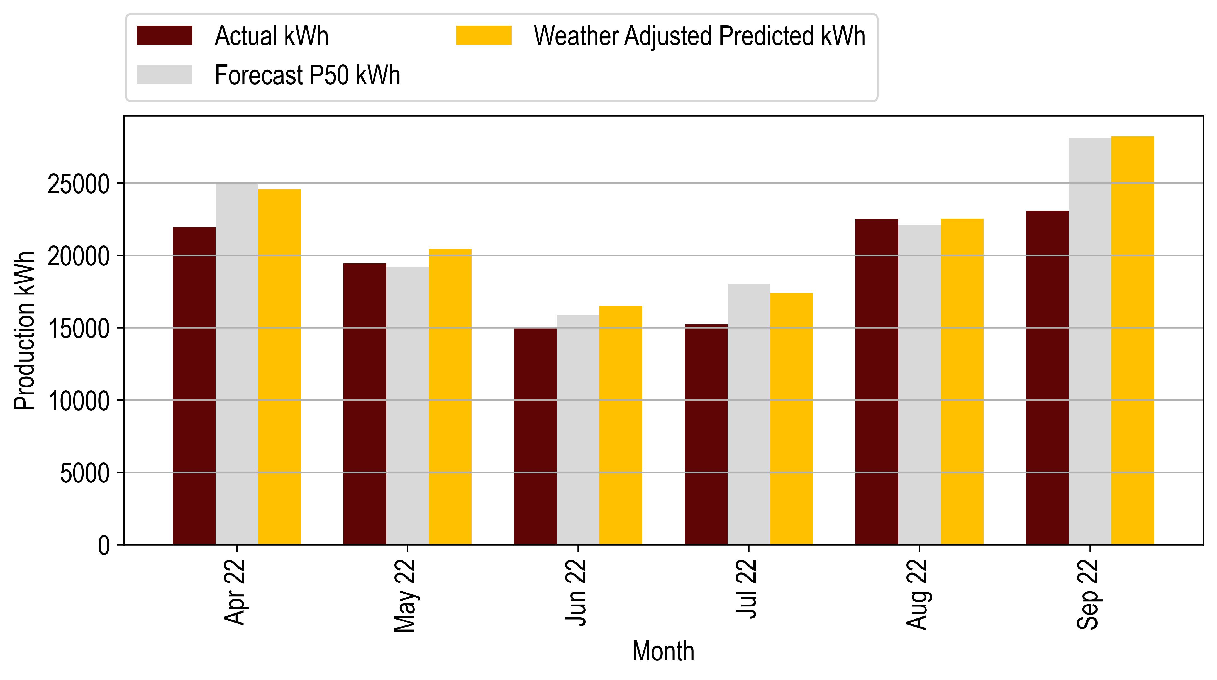

*Figure 7‑1: Hermanus Production Vs Forecast*

## Hermanus Performance Ratio vs Forecast



|  |  |  |  |
| --- | --- | --- | --- |
| **Performance Ratio (%)** | | | |
| **Month** | **Actual** | **Forecast** | **Delta (%)** |
| Apr 22 | 78 | 80 | -2.76 |
| May 22 | 82 | 87 | -5.8 |
| Jun 22 | 79 | 87 | -8.85 |
| Jul 22 | 76 | 87 | -12.35 |
| Aug 22 | 88 | 88 | 0.05 |
| Sep 22 | 70 | 87 | -20.14 |

*Table 7‑5: Hermanus PR and Forecast*

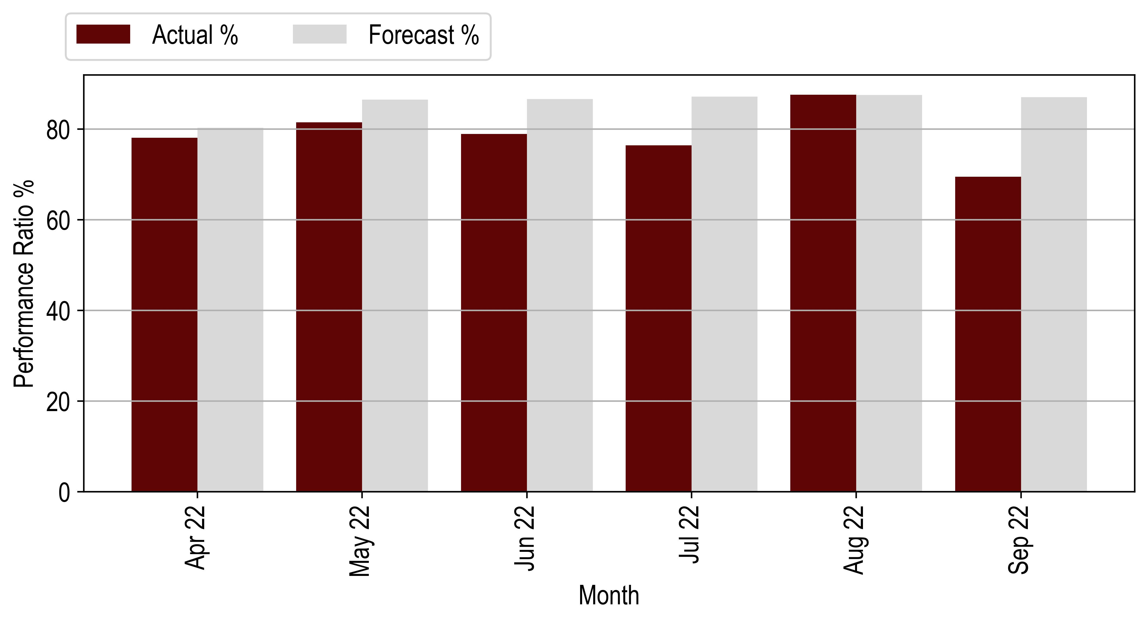

*Figure 7‑5: Hermanus PR Vs Forecast*

## Hermanus Production vs Forecast

|  |  |  |  |  |  |
| --- | --- | --- | --- | --- | --- |
| **Month** | **Production (kWh)** | | | **Actual vs Original Forecast (%)** | **Actual vs Weather Adjusted Forecast (%)** |
|  | **Original Forecast** | **Weather Adjusted Forecast** | **Actual Production** |
| Apr 22 | 24970 | 24557 | 21947 | -12.11 | -10.63 |
| May 22 | 19205 | 20441 | 19453 | 1.29 | -4.83 |
| Jun 22 | 15902 | 16522 | 15026 | -5.51 | -9.05 |
| Jul 22 | 18020 | 17408 | 15238 | -15.44 | -12.46 |
| Aug 22 | 22128 | 22535 | 22528 | 1.81 | -0.03 |
| Sep 22 | 28140 | 28241 | 23106 | -17.89 | -18.18 |
| **Total** | **128364** | **129703** | **117298** | **-8.62** | **-9.56** |

Table 7‑2: Hermanus Production and Forecast



Figure 7‑1: Hermanus Production Vs Forecast



# Vergelegen Technical Performance

The following table gives a brief overview of the Vergelegen PV installation

|  |  |
| --- | --- |
| **Project Overview** | |
| Design Capacity DC/AC (kW) | 697.1 / 650 |
| Achieved Capacity DC/AC (kW) | 689.6 / 650 |
| Technology | Solar |
| Project Company: | Moshesh Solar PV 1 (Pty) Ltd |
| Address: | Vergelegen, Main Road Somerset West South Africa |
| Commercial Operation Date | 28 October 2022 |

Table ‑: Vergelegen Project Overview

## Vergelegen Irradiation Vs Forecast

|  |  |  |  |  |  |  |  |
| --- | --- | --- | --- | --- | --- | --- | --- |
| **Irradiation (kWh/m2)** | | | | | | | |
| **Month** | | | **Actual** | | | **Forecast** | **Delta (%)** |
| Jan 22 | | | 247 | | | 252 | -2.04 |
| Feb 22 | | | 199 | | | 203 | -2.02 |
| Mar 22 | | | 173 | | | 186 | -7.3 |
| Apr 22 | | | 132 | | | 128 | 3.16 |
| May 22 | | | 92 | | | 91 | 0.74 |
| Jun 22 | | | 79 | | | 74 | 6.92 |
| Jul 22 | | | 75 | | | 83 | -9.41 |
| Aug 22 | | | 97 | | | 107 | -9.72 |
| Sep 22 | | | 133 | | | 146 | -8.55 |

*Table 8‑3: Vergelegen irradiation and Forecast*

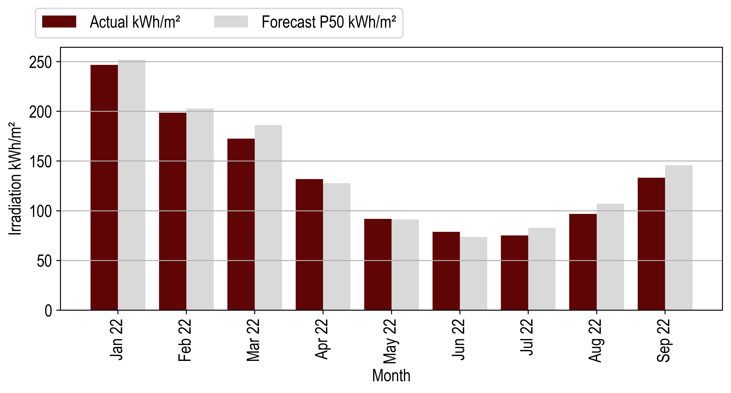

*Figure 8‑3: Vergelegen Irradiation Vs Forecast*

## Vergelegen Availability vs Forecast



|  |  |  |  |
| --- | --- | --- | --- |
| **Availability (%)** | | | |
| **Month** | **Actual** | **Forecast** | **Delta (%)** |
| Jan 22 | 99 | 95 | 4.03 |
| Feb 22 | 99 | 95 | 4.52 |
| Mar 22 | 100 | 95 | 5.26 |
| Apr 22 | 97 | 95 | 1.93 |
| May 22 | 99 | 95 | 4.48 |
| Jun 22 | 92 | 95 | -3.14 |
| Jul 22 | 92 | 95 | -3.53 |
| Aug 22 | 99 | 95 | 4.65 |
| Sep 22 | 93 | 95 | -1.65 |

Table 8‑4: Vergelegen Availability and Guaranteed

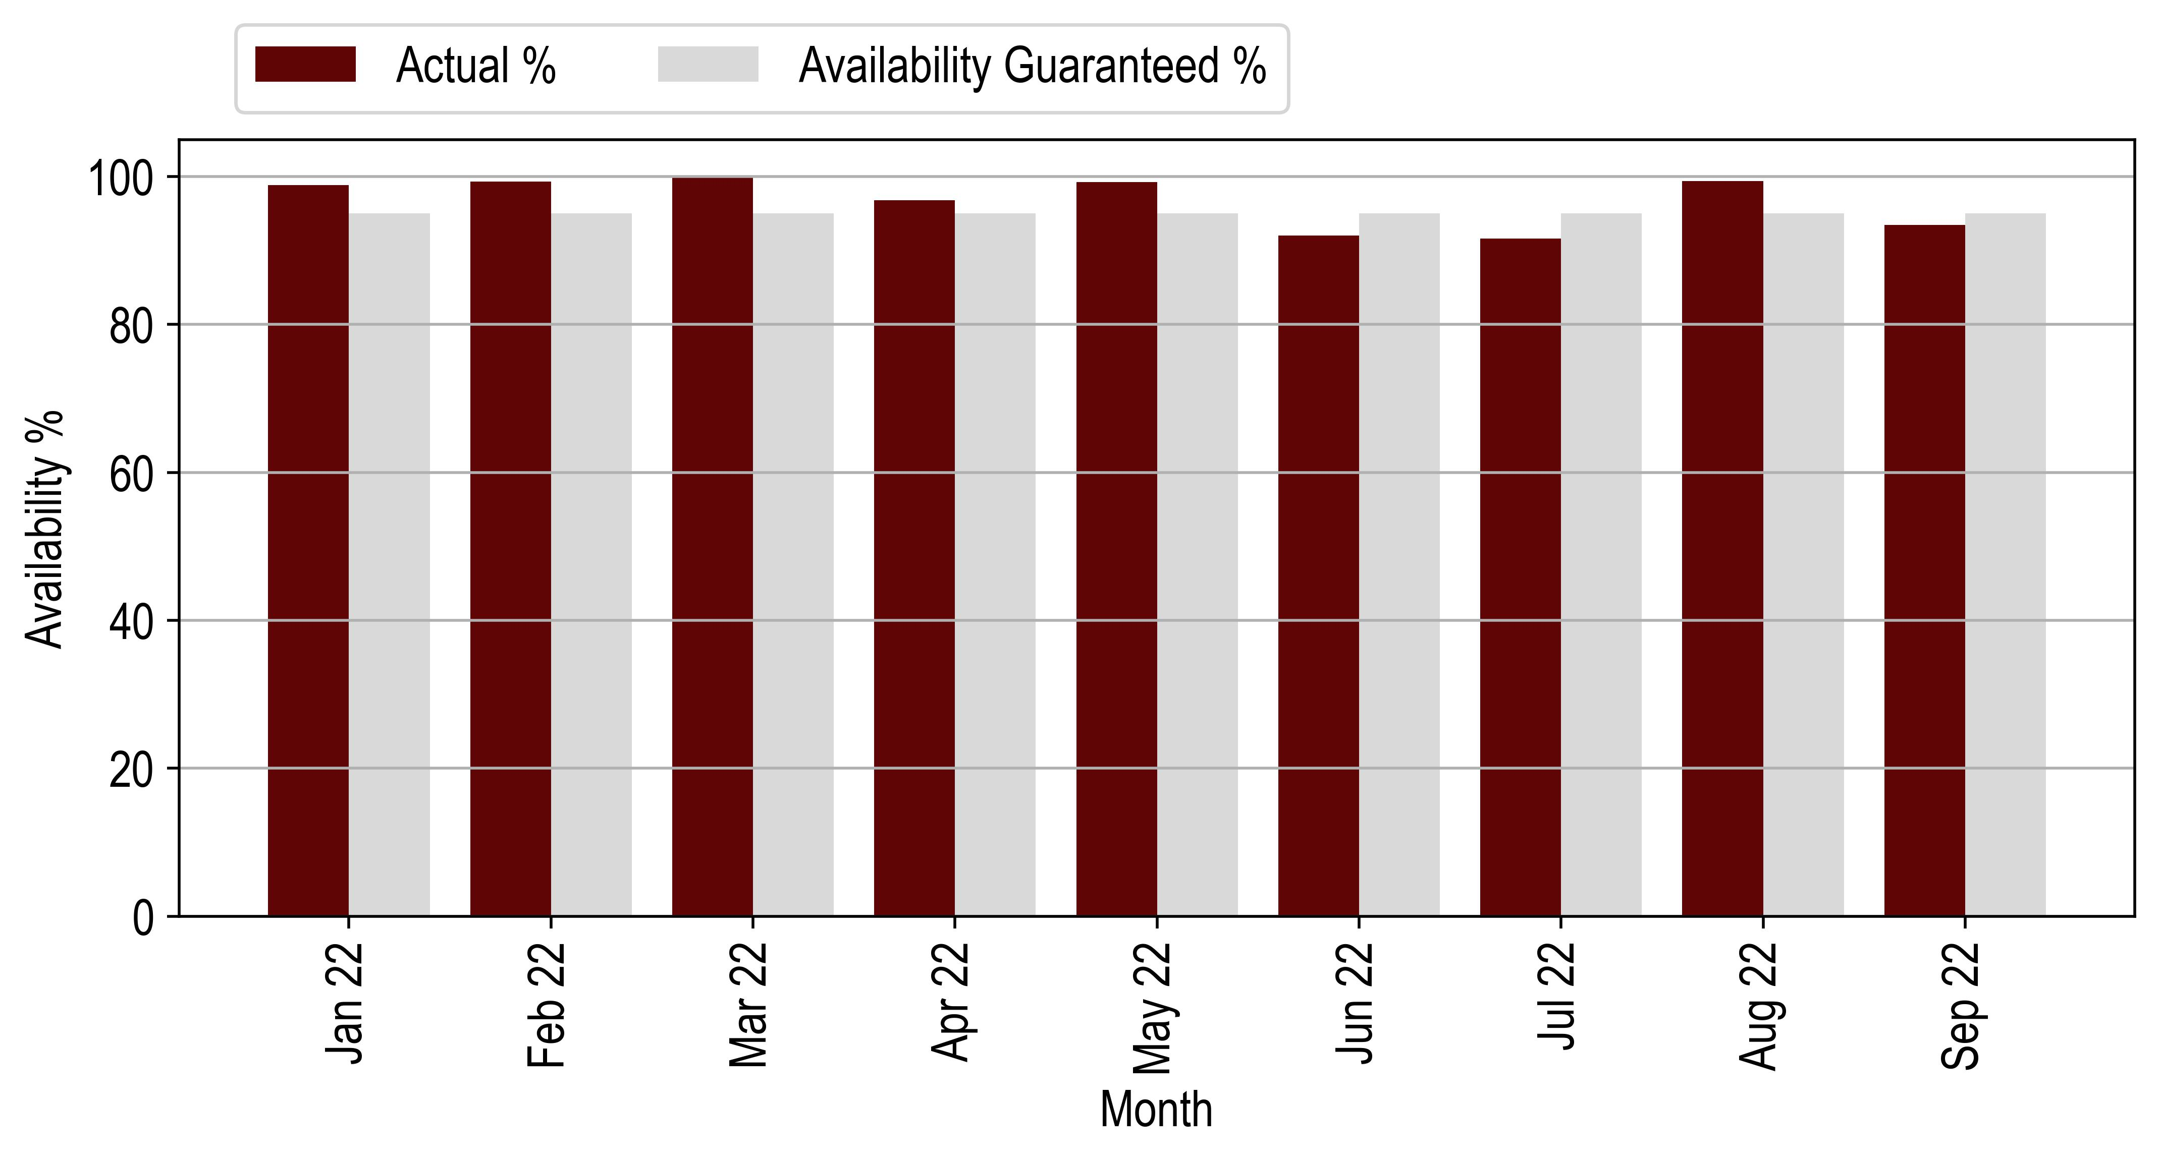

Figure 8‑4: Vergelegen Availability Vs Forecast

## Vergelegen Performance Ratio vs Forecast

|  |  |  |  |
| --- | --- | --- | --- |
| **Performance Ratio (%)** | | | |
| **Month** | **Actual** | **Forecast** | **Delta (%)** |
| Jan 22 | 74 | 0 | 0 |
| Feb 22 | 70 | 0 | 0 |
| Mar 22 | 79 | 0 | 0 |
| Apr 22 | 76 | 69 | 10.13 |
| May 22 | 82 | 81 | 0.73 |
| Jun 22 | 72 | 82 | -12.8 |
| Jul 22 | 81 | 80 | 1.57 |
| Aug 22 | 90 | 83 | 8.92 |
| Sep 22 | 79 | 82 | -2.71 |

*Table 8‑5: Vergelegen PR and Forecast*

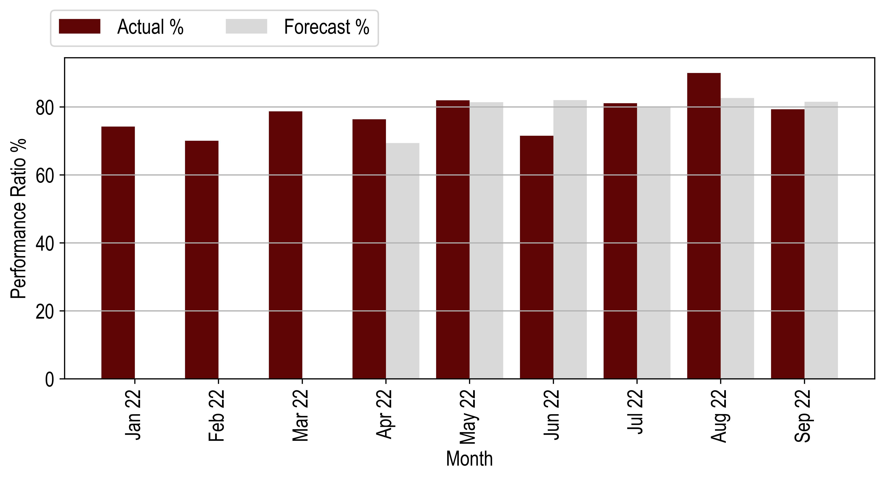

*Figure 8‑5: Vergelegen PR Vs Forecast*



## Vergelegen Production vs Forecast

|  |  |  |  |  |  |
| --- | --- | --- | --- | --- | --- |
| **Month** | **Production (kWh)** | | | **Actual vs Original Forecast (%)** | **Actual vs Weather Adjusted Forecast (%)** |
|  | **Original Forecast** | **Weather Adjusted Forecast** | **Actual Production** |
| Jan 22 | 134331 | 134331 | 127625 | -4.99 | -4.99 |
| Feb 22 | 108571 | 108571 | 96946 | -10.71 | -10.71 |
| Mar 22 | 100729 | 100729 | 94648 | -6.04 | -6.04 |
| Apr 22 | 70911 | 73155 | 70139 | -1.09 | -4.12 |
| May 22 | 51576 | 51960 | 52488 | 1.77 | 1.02 |
| Jun 22 | 41982 | 44887 | 39238 | -6.54 | -12.58 |
| Jul 22 | 47500 | 43033 | 42440 | -10.65 | -1.38 |
| Aug 22 | 61453 | 55477 | 60653 | -1.3 | 9.33 |
| Sep 22 | 82460 | 75410 | 73643 | -10.69 | -2.34 |
| **Total** | **699513** | **687553** | **1022270** | **-5.96** | **-4.32** |

*Table 8‑2: Vergelegen Production and Forecast*

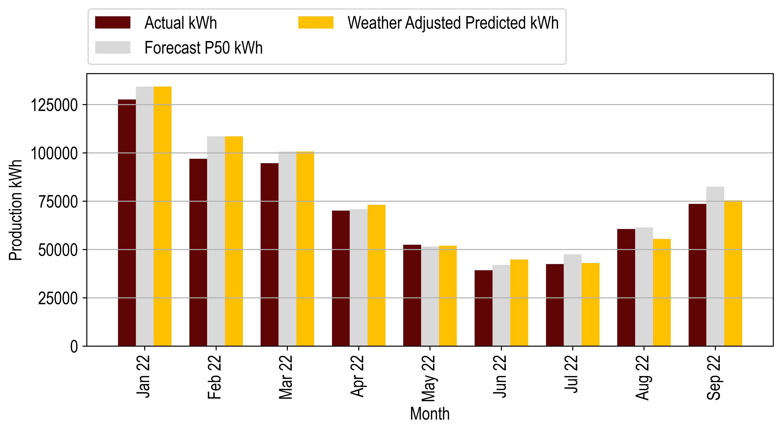

*Figure 8‑1: Vergelegen Production Vs Forecast*



# Events

## Health and Safety

No health and safety incidences were reported based on the information provided by the Operator.

## Scheduled Maintenance

## Unscheduled Maintenance







# Documents Reviewed

|  |  |
| --- | --- |
| **Project Name** | **Documents Reviewed** |
| Vergelegen | * Vergelegen April 2022 * Vergelegen February 2022 * Vergelegen December 2022 * Vergelegen July 2022 * Vergelegen June 2022 * Vergelegen March 2022 * Vergelegen January 2022 * Vergelegen November 2022 * Vergelegen August 2022 * Vergelegen August 2022 |
| Durbanville | * Durbanville April 2022 * Durbanville February 2022 * Durbanville December 2022 * Durbanville July 2022 * Durbanville June 2022 * Durbanville March 2022 * Durbanville January 2022 * Durbanville August 20,222 * Durbanville September 2022 |
| Midstream | * Midstream April 2022 * Midstream February 2022 * Midstream December 2022 * Midstream July 2022 * Midstream June 2022 * Midstream March 2022 * Midstream January 2022 * Midstream November 2022 * Midstream August 2022 * Midstream September 2022 |
| Hermanus | * Hermanus April 2022 * Hermanus July 2022 * Hermanus June 2022 * Hermanus May 2022 * Hermanus August 2022 * Hermanus September 2022 |
| Highveld | * Highveld April 2022 * Highveld July 2022 * Highveld June 2022 * Highveld May 2022 * Highveld August 2022 * Highveld September 2022 |

Appendix 1 Unscheduled Maintenance

The following table describes the unscheduled maintenance activities that have been reported since COD:

|  |  |  |  |  |
| --- | --- | --- | --- | --- |
| **Date Occurred** | **Plant** | **Events** | **Description** | **Resolution** |
| 9/5/2022 | Durbanville | The communication was down and the inverters were not producing. | Communication between inverters and logger was interrupted and inverters showed no production - idle status.  It has been determined that the UPS for communication on block 3 failed, causing communication to be interrupted. The UPS failed without external causes. | The UPS was repaired on 10 May 2022. The estimated production downtime was 2MWh. |
| 9/5/2022 | Durbanville | Inverter 5 - no production - string fault. | The inverter went into fault mode because one string had an abnormal voltage reading to earth.  String 5.4.1 had an insulation fault and there was a voltage leakage into the earth system.  The fault could not be corrected within 24 hours because no team was available at that time to lift the equipment and find the fault. | On 27 May 2022, the faulty string was disconnected from the inverter to resume production, and a new connector was attached to the undamaged piece of cable.  The fault resulted in a production loss of 175 kWh. |
| 3/7/2022 | Durbanville | Inverters 4 to 7 no production | No link between the logger and inverters 4 to 7.  The UPS for the PA link failed | On 4 July 2022,  a new part (UPS) was installed  The production loss hour was 1.1MW |
| 23/08/2022 | Durbanville | Theft | The main earthing cable of the solar system was stolen (7 meters) behind the green tanks on the roof slab. | The earthing cable parts that were stolen have been replaced. Harmattan have also submitted the incident to the insurer to understand the excess on the claim. The insurer has stated a minimum detectable of R15,000 for theft. Since the total replacement cost for cable was R4,945.00. Harmattan note that the incident cost is too low vs the excess required by the insurer. |
| 22/02/2022 | Vergelegen | Block 1, inverter 2, large DC of output current | Inverter 2 had a string fault that caused a high output DC current.  It was determined on site that inverter 2, string 2.2.1, had an open circuit voltage reading. The MC4 connection on the module array of string 2.2.1 failed due to a hot connection and melted, causing an open circuit connection. | On 23 February 2022, the MC4 was removed, the cables were reconnected, and a new MC4 was installed and properly connected to ensure continuity. The string was retested and found to be functional.  The estimated production loss is 68.85 kWh. |
| 25/05/2022 | Hermanus | Main circuit breakers not switching on | The main circuit breakers at the feeder and PVDB did not want to turn on automatically.  It was determined on site that the UFD, which automatically turns the circuit breakers on and off, had failed. | 0n 26 May 2022, the UFD was replaced by another UFD.  The production downtime was 900kWp |